V0.8 Published July 2021

Technical Conformance Testing Guidance

National Record Locator

**Contents**

Revision History 3

Glossary of Terms 3

Overview 4

End to End Process 4

Test Stages 4

Conformance Testing Evidence 4

Testing NRL Interactions (Local) 6

Toolkit Workbench 6

Prerequisites 6

Installing the TKW 6

TKW Components 7

Install Integrity Check 10

Testing NRL Interactions (INT) 12

Test Data 12

Test Portal 12

OpenTest Environment 12

Running Tests 13

Record Upload 13

NRL document Record Interaction 14

SSP Retrieval Request 15

# Revision History

|  |  |  |
| --- | --- | --- |
| Version | Date | Summary of Changes |
| V0.1 | 17.09.2019 | Initial draft |
| V0.2 | 23.09.2019 | Clarifications following review |
| V0.3 | 24.09.2019 | Add screenshots of SCAL and Test Cases and update retrieval testing guidance |
| V0.4 | 26.09.2019 | Update retrieval testing guidance |
| V0.5 | 01.10.2019 | Embed triggers replaced with link to GitHub location |
| V0.6 | 30.10.2019 | Update testing provider retrieval instructions for v0.7 of the retrieval app  Added limitations of TKW validation  Change GitHub locations |
| V0.7 | 01.03.2021 | Added consumer retrieval testing guidance  Minor restructure of provider retrieval testing guidance  Updates to include test portal |
| V0.8 | 20.07.2021 | Updated document to include OpenTest access to test portal |

# Glossary of Terms

|  |  |
| --- | --- |
| Term / Abbreviation | What it stands for |
| API | Application Programming Interface |
| Client | Consumer or Provider software supplier |
| HTTP | HyperText Transfer Protocol |
| INT | NHS Digital Integration Test Environment. This is one of the PTL environments |
| NRL | National Record Locator |
| PTL | Path to Live |
| SCAL | Supplier Conformance Assessment List |
| SSP | Spine Secure Proxy |
| TKW | Toolkit Workbench |

# Overview

The National Record Locator (NRL) enables an authorised clinician, care worker and/or administrator, in any health and care setting, to access a patient’s information to support that patient’s direct care. Further details can be found on the [NRL specification](https://developer.nhs.uk/apis/nrl).

This document is a guide to conformance testing for solutions integrating with the NRL API.

## End to End Process

The end-to-end process for testing and technical conformance is described in the diagram below:

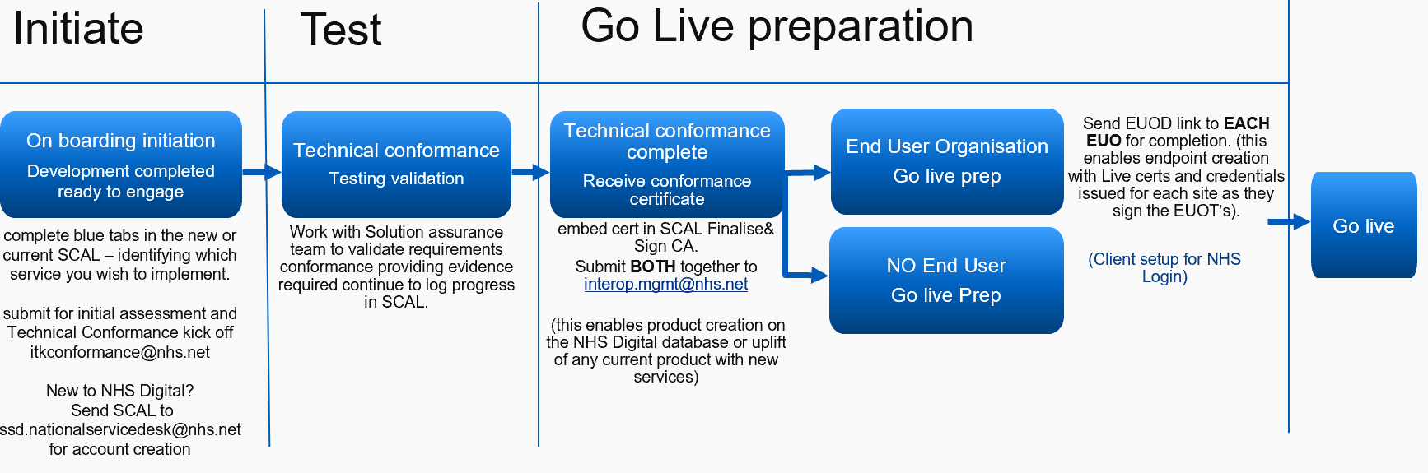

## Test Stages

The test stages for completing technical conformance are as follows:

1. Local testing of NRL API interactions using the Toolkit Workbench (TKW)
2. Testing NRL API interactions in NHS Digital hosted PTL test environments
3. Testing Information Retrieval via SSP in NHS Digital hosted PTL test environments (if in scope)

Further detail and instructions for each testing stage can be found in the sections below.

Note that to test solutions in the NHS Digital hosted PTL test environments, suppliers must have first completed local testing. Instructions for endpoint registration can be found in the [NRL Onboarding Guide for Direct API Integration](https://github.com/nhsconnect/FHIR-NRLS-API/tree/develop/content/uploads/onboarding).

## Conformance Testing Evidence

### SCAL

The supplier conformance assessment list (SCAL) maps all the requirements needed to interface with a specific service to the evidence required during the technical conformance process. SCAL evidence consists of both test evidence (see **Test Cases**)and statements.

### 

Figure 1 SCAL Requirement Example

### Test Cases

Clients will be provided with a Test Cases document which details the tests for assessing technical conformance. Each test case details the individual test steps, with expected outcomes and required evidence (see **Evidence Files**below). The test cases cover both local testing and testing in the NHS Digital hosted test environments.

### 

Figure 2 Test Case Example

### Scope

The SCAL and Test Cases document will be scoped for each Client. Clients must only complete and submit evidence for requirements and tests that are in scope. If you have any questions about the scope, please contact [nrlnems.ls@nhs.net](mailto:nrlnems.ls@nhs.net).

### Evidence Files

Each test case specifies the evidence which must be submitted to Solutions Assurance. A directory structure is provided to organise the test evidence and ensure that the assurance process is thorough and is completed efficiently.

The structure contains an empty directory for each test case number. The evidence files for each test must be placed in the appropriate directory in the structure.

### Submitting Test Evidence

When testing is complete, please submit your SCAL, test cases document and evidence files (in provided structure) to [itkconformance@nhs.net](mailto:itkconformance@nhs.net). This should be done at 2 stages:

1. After local testing is complete
2. After testing in NHS Digital INT environment is complete

Validation and test reports should be reviewed before submitted evidence to ensure all issues are resolved, where possible.

# Testing NRL Interactions (Local)

NRL interactions for managing pointers and pointer retrieval are tested locally using the Toolkit Workbench (TKW).

## Toolkit Workbench

The TKW is an application that can be run locally to test conformance of a solution against a defined NHS Digital API specification. The purpose of the TKW is to test and validate both success and error scenarios for API interactions and ensure that audit capabilities are in place.

TKW evidence must be submitted to NHS Digital’s Solutions Assurance team before connection to the hosted test environments is set up. For more information, see the **Evidence** section.

## Prerequisites

* JRE installed on system the TKW will run on
* Capability to run .bat file (e.g. Windows operating system)

## Installing the TKW

1. Download the latest version of the NRL TKW Installer jar file from Github:  
   <https://github.com/nhsconnect/FHIR-NRLS-API/tree/develop/content/uploads/onboarding/assurance>
2. Install the TKW to your preferred location on your PC by running the installer.

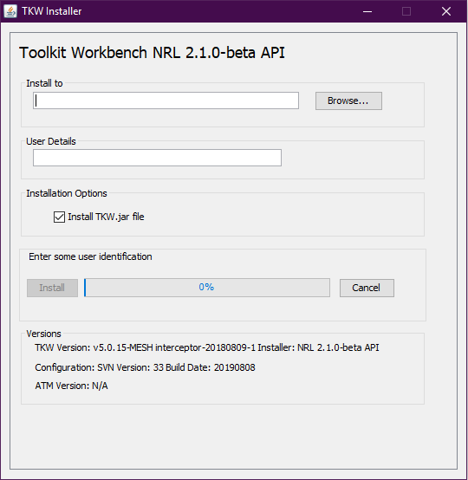

Figure 3 TKW Installer

The a TKW directory will be created in the location specified, with contents as shown in the image below.

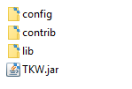

Figure 4 TKW Directory

## TKW Components

The TKW consists of 3 main components:

1. Simulator – simulates responses from NRL
2. Transmitter – transmits HTTP requests
3. Validator – validates requests sent to the simulator

### Simulator

The simulator acts as a stub API responder to simulate responses for NRL interactions. HTTP requests can be sent to the simulator and the appropriate success or error response will be returned.

#### Triggers

The simulator is configured to respond to a set of triggers. The triggers are defined for success and error scenarios for each interaction as defined on the NRL specification. The SCAL and Test Cases document will list the triggers for which you need to submit evidence (see the **Conformance Testing Evidence** section for further detail). The complete list of NRL triggers can be used for test purposes and it is recommended that the tests for all error scenarios are run.

Note that triggers exist for Consumers to test information retrieval interactions with the SSP, however an empty response body is returned for the success scenario trigger (HTTP 200 status code).

Full list of NRL TKW Triggers can be found on Github at the following address:

<https://github.com/nhsconnect/FHIR-NRLS-API/tree/develop/content/uploads/onboarding/assurance>

#### Instructions

1. Navigate to ***TKW/config/SPINE_NRLS/TestRun***

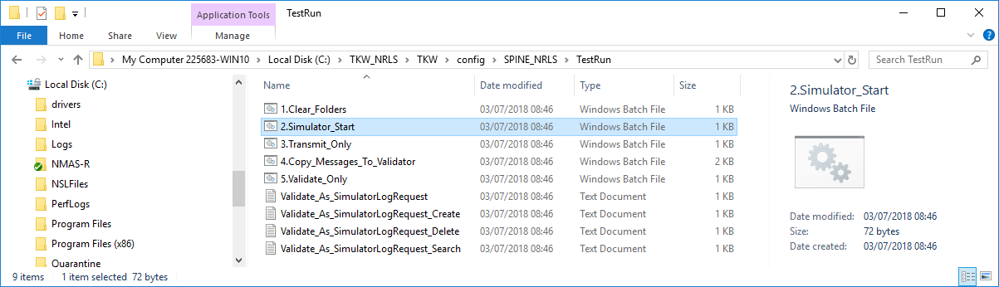

Figure 5 TestRun Directory

1. Run ***2.Simulator_Start.bat*** to run the simulator, you should see a command prompt window open in the background.

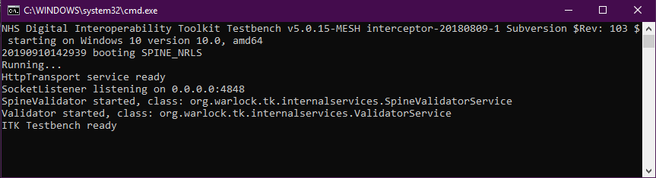

Figure 6 Simulator Command Prompt

1. By default, the simulator listens on <http://127.0.0.1:4848>. This can be changed in the file ***TKW/config/SPINE_NRLS/tkw.properties***
2. HTTP requests can be made to the TKW using the interactions defined on the [NRL specification](https://developer.nhs.uk/apis/nrl/) and the variables/parameters defined for each trigger.

Note that the simulator is a stub responder based on the triggers and will not validate all technical requirements for the HTTP request. The request can be validated using the TKW validator as described in the **Validator**section below. Each request should be validated individually.

#### Request Logs

Each HTTP request to the TKW simulator is logged with the response in the directory ***TKW/config/SPINE_NRLS/simulator_saved_messages****.* A log file is created for each request.

The request and response logs are required for validation and TKW evidence.

Note that the filenames should remain unchanged in order to work with the TKW validator.

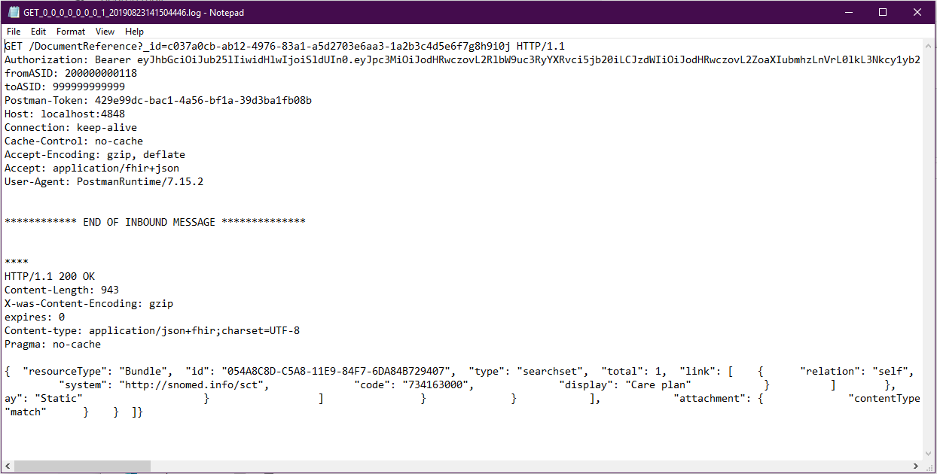

Figure 7 Example Request Log

### Validator

The TKW validator tests the HTTP requests against the NRL pointer model and associated business rules, using the simulator request logs. The validator produces a report which identifies issues with conformance to the API specification.

Note that requests should be validated individually to supply evidence for separate test cases.

Please note the validator does not check against the specified value sets for the following attributes of the NRL-DocumentReference-1 profile:

* DocumentReference.class
* DocumentReference.type
* DocumentReference.content.format
* DocumentReference.context.practiceSetting

#### Instructions

1. Navigate to ***TKW/config/SPINE_NRLS/TestRun***
2. Run ***4.Copy_Messages_To_Validator.bat***to copy the request logs from ***TKW/config/SPINE_NRLS/simulator_saved_messages*** to ***TKW/config/SPINE_NRLS/messages_for_validation***

The request logs must **not** be copied manually, as this process prepends an interaction ID to each file to determine the validation rules for the interaction.

Note that this step is only required for success scenarios.

1. Run ***5.Validate_Only.bat*** to validate all request messages in the ***TKW/config/SPINE_NRLS/messages_for_validation***directory.

This step will produce a validation report (.html file) in the ***TKW/config/SPINE_NRLS/validator_reports***directory

1. Review the validation report produced in step 3.

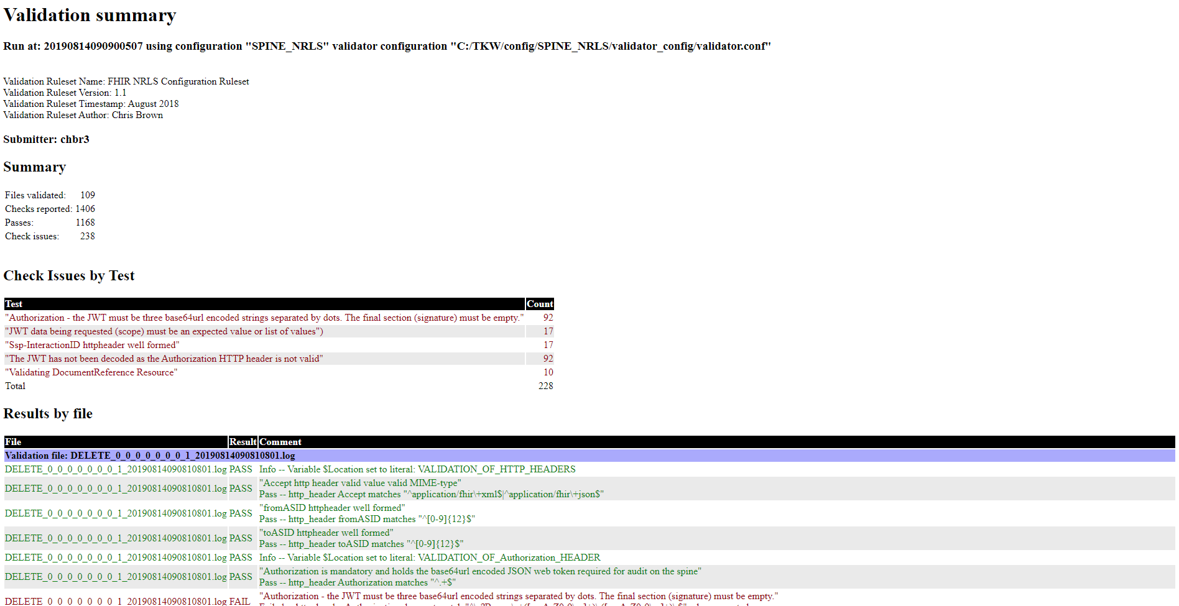

Figure 8 Example Validation Report

The validation report includes a summary and count of test issues and detail of the test results for each HTTP request. Any issues should be addressed before submitted test evidence to NHS Digital.

## Install Integrity Check

An integrity check can be run to test the install of the TKW. This is done using the transmitter to send a test request to the TKW.

### Transmitter

The TKW transmitter can be used to send HTTP requests to test an endpoint. The request details can be configured in the file ***TKW/config/SPINE_NRLS/tkw.properties***.

On installing the TKW, the configuration is set to test the Search by Subject trigger with patient NHS Number 9462205655.

### Integrity Check Instructions

1. Navigate to ***TKW/config/SPINE_NRLS/TestRun***
2. Run ***2.Simulator_Start.bat*** to run the simulator, you should see a command prompt window open in the background.
3. Run ***3.Transmit_Only.bat*** to run the transmitter and send the test HTTP request to the simulator
4. Run ***4.Copy_Messages_To_Validator.bat*** to copy the request logs from ***TKW/config/SPINE_NRLS/simulator_saved_messages*** to ***TKW/config/SPINE_NRLS/messages_for_validation***
5. Run ***5.Validate_Only.bat*** to validate the request message

This step will produce a validation report (.html file) in the ***TKW/config/SPINE_NRLS/validator_reports***directory

# Testing NRL Interactions (INT)

When local testing has been completed successfully and reviewed by the NHS Digital Solutions Assurance team, suppliers can begin testing solutions in the NHS Digital INT environment.

Instructions for setting up access to the INT environment can be found in the [NRL Onboarding Guide for Direct API Integration](https://github.com/nhsconnect/FHIR-NRLS-API/tree/develop/content/uploads/onboarding)

Evidence for testing in INT will need to be submitted:

1. Completion of Test Cases document
2. Evidence files (placed in appropriate directory in the provided structure)

See the **Conformance Testing** **Evidence**section above for further detail.

Note that some test cases may require the involvement of the NHS Digital Solutions Assurance team to check the test environment database and audit logs. All other tests in scope must be completed with evidence submitted before it can be arranged for these tests to take place.

## Test Data

The following test data will be required for testing NRL interactions in INT:

* Provider – NHS numbers for test patients
* Consumer – NHS numbers for test patients with pointers created for each test case

Some of the test data required is outlined in the Test Cases document. If additional test data is required, contact the NHS Digital Test Data team: [testdata@nhs.net](mailto:testdata@nhs.net).

# Test Portal

Testing in the INT environment is done using the NRL test portal, including retrieval via the SSP. The online portal can be accessed through this link:

<http://itw-work.itblab.nic.cfh.nhs.uk>

An account is required to access the portal – this can be set up through the live services team.

The test portal is available directly via a HSCN connection, but tests can also be run in INT via the test portal through the OpenTest environment, which does not require a HSCN connection.

## Test Portal Via OpenTest

Where a system is connecting to NRL using the internet gateway and does not have a HSCN connection, the testing can be performed via the test portal in the OpenTest environment. Information on OpenTest how to request access can be found on the following page:

<https://digital.nhs.uk/services/spine/open-access-test-environment-for-spine-opentest>

As per the test portal in the INT environment, an account is required to access the portal which can be set up through the live services team. Once connected to the OpenTest environment, via the VPN, you can access the NRL test portal at the following link:

<http://192.168.128.22/Login.aspx>

## Running Tests

When you have logged into the test portal, you should see this page:

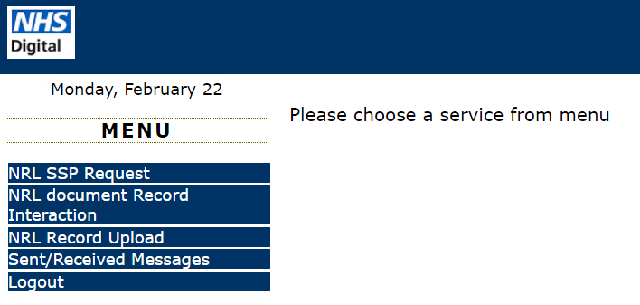

The various options are described in the detail below.

## Record Upload

The “NRL Record Upload” page allows you to upload a document, such as a PDF or XML file, which will be stored and can be accessed via the SSP in order to test retrieval.

The intended use for this interaction is to mock a Provider retrieval endpoint for suppliers acting as NRL Consumers to test information retrieval via the SSP in the NHS Digital hosted environments.

The content of the response body for record retrieval is out of scope for NRL conformance testing, but suppliers can use the portal to simulate any relevant error scenarios for processing and displaying the data retrieved from a Provider endpoint.

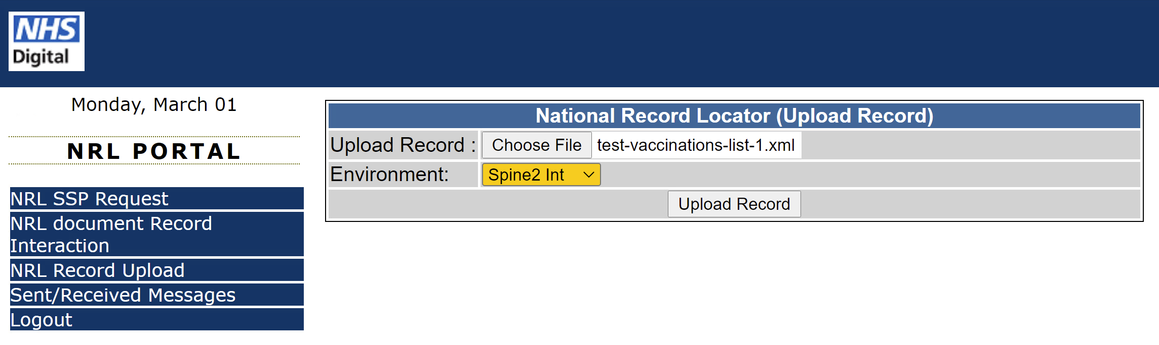

When a record is uploaded, the test portal will return the following details for the endpoint to be used in the information retrieval request:

* Endpoint URL
* ASID (to be used in the SSP-To header)

An example of this can be seen in the screenshot below:

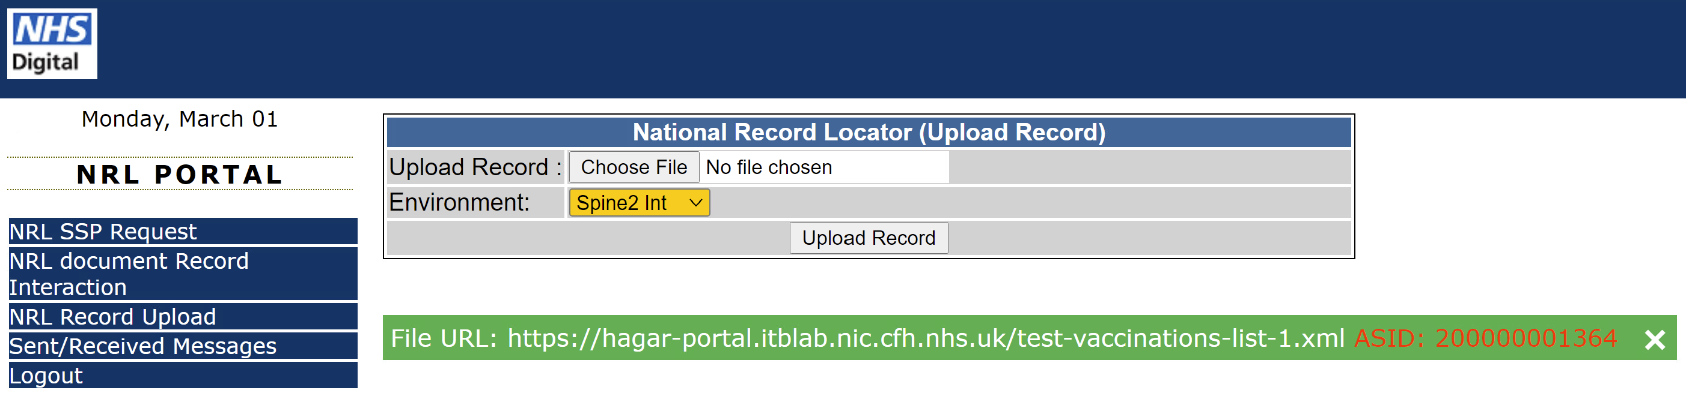

## NRL document Record Interaction

The “NRL Document Record Interaction” page allows a user to interact with the NRL using the following interactions:

* Search for Pointers (Provider Testing)
* Create Pointer (Consumer Testing)
* Delete Pointer (Consumer Testing)

The `create` and `delete` interactions allow for NRL consumers to set up pointers in the test environment which can then be used for testing within their NRL Consumer system.

The `search` interaction allows providers to retrieve pointers they have created within the test environment.

### Creating Pointers Using The Portal

When creating a pointer using the portal, a file containing the pointer to be created needs to be selected and uploaded. This file needs to be a JSON file containing the pointer FHIR DocumentReference that you want creating on the NRL in the test environment, such as the example file below:



In the INT environment the custodian element must contain the ODS code “RHM”, but access via the OpenTest environment it must be “X26”.

The pointer file can be updated, before creating the pointer, to include the URL returned by the record upload interaction in test portal, document type and retrieval format to allow end to end testing by a consumer.

### Providing Evidence

The following evidence will need to be provided for testing Consumer information retrieval:

* Supplier system screenshots
* Supplier system audit logs

Further detail on providing evidence can be found in the test cases spreadsheet. Tests must cover at least one positive case (record found) and at least one negative case (e.g. record not found). As described above, the content of the response body for information retrieval is out of scope for NRL conformance testing.

## SSP Retrieval Request

The “NRL SSP Request” page on the portal allows a user to retrieve information through the SSP using the [SSP Retrieval Interaction](https://developer.nhs.uk/apis/nrl/retrieval_ssp.html). You will need to input the retrieval URL from the pointer and the ASID for the retrieval endpoint. The URL does not need to be prefixed with the SSP base URL as this will be done by the test portal.

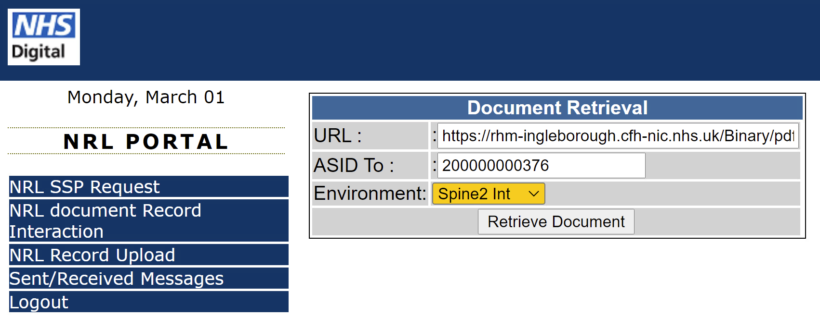

If the request is successful, you should see the pop up as in the screenshot below:

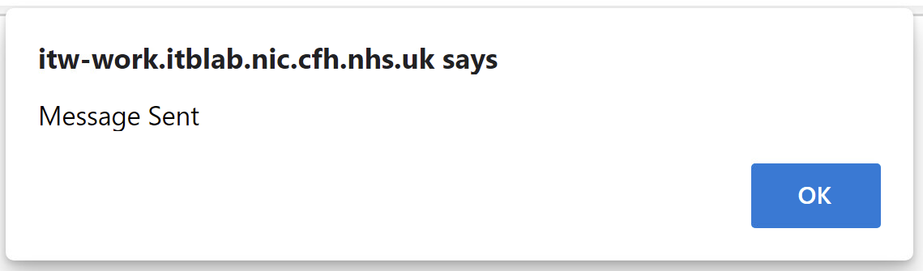

The request log and request body can be found under “Sent/Received Messages” (in separate files), and can be used as conformance test evidence.   
  
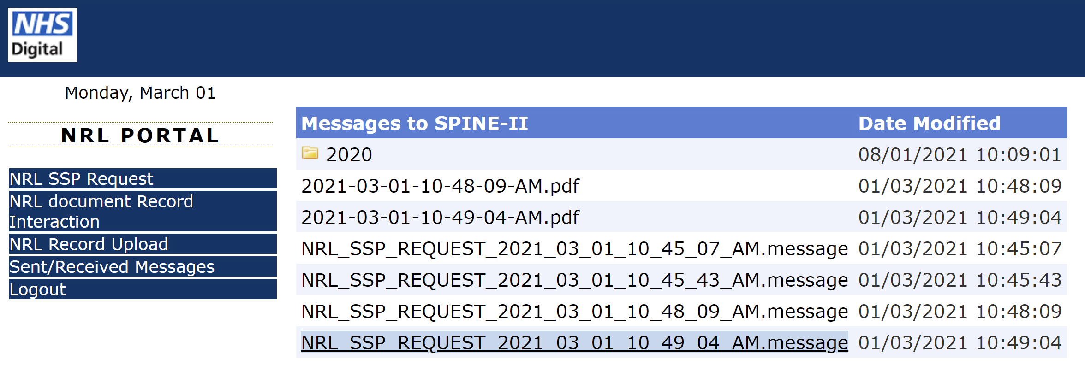

### Providing Evidence

As described above, the request log and request body files can be used as conformance test evidence for Provider information retrieval.

Tests must cover at least one positive case (record found) and at least one negative case (e.g. record not found).